  - Introduction to Project Theme:

In modern software development, managing changes to source code efficiently has become a critical requirement. As software applications increase in size and complexity, multiple developers often work simultaneously, making frequent updates, enhancements, and bug fixes. Without a structured mechanism to track these changes, maintaining consistency, reliability, and accuracy of the code becomes difficult. This challenge is effectively addressed by Version Control Systems (VCS), which maintain a record of file modifications and preserve historical versions of data.
The proposed project focuses on the development of a simplified web-based Version Control System, inspired by platforms such as GitHub. The objective is not to replicate the complete distributed architecture of Git, but to demonstrate the core principles of version management in a simplified and understandable manner. The system primarily concentrates on repository creation, file versioning, and commit history tracking, thereby reducing technical complexity while preserving the essential functionality of a version control system.
This project is designed as an academic prototype using modern web technologies. It provides users with a centralized platform to manage repositories and monitor file changes over time. By implementing this system, the project aims to bridge the gap between theoretical concepts of version control and their practical application in real-world software development environments.
The core objective of the project is to replace traditional manual processes with a structured, database system that stores all information in tabular format using a SQL database. This structured approach allows quick access to data, better monitoring and accurate maintenance of records. The system also supports easy generation of reports, which helps to analyse data, track performance and make informed decisions.

  - Working of System:

The Repository Management System follows a client–server architecture, where the frontend communicates with the backend using HTTP requests and responses. Users interact with the system through a web-based interface developed using HTML, CSS, and JavaScript, which ensures ease of access and usability.
The working of the system can be summarized as follows:
- Users access the system and perform authentication through a secure login process.
- After successful authentication, users are redirected to a structured dashboard.
- Users can create new repositories, upload files, and modify existing files through the dashboard interface.
Each user request is validated and processed by the backend developed using Python and the Flask framework.
Whenever a user modifies a file and saves the changes, the system creates a new version entry instead of overwriting the existing file. Each version contains:
- Version number
- Updated file content
- Commit message
- Timestamp
- Author information
All version-related data is stored securely in a MySQL database, allowing users to view, compare, or restore previous versions when required. This process effectively simulates the concept of commits found in traditional version control systems.

  - Need & Scope of Proposed System:

Need of the Proposed System -
The need for the proposed system arises from the growing importance of version control knowledge in the software development industry. Although professional platforms like GitHub provide advanced features, their internal working mechanisms are often complex and difficult for beginners to understand.

The proposed system addresses the following needs:
- Simplified understanding of version control concepts
- Centralized repository management
- Elimination of manual file backups
- Prevention of accidental data loss
- Improved tracking of file changes and updates
By maintaining a structured version history, the system improves accountability and enables users to revert to earlier versions whenever required.

Scope of the Proposed System -
The scope of the system is primarily limited to basic version control functionalities suitable for academic and learning purposes. These include:
- Repository creation and management
- File versioning
- Commit history tracking
- Centralized data storage
Although limited in scope, the system is designed to be scalable. In the future, it can be extended to include:
- Branching and merging
- Role-based access control
- Detailed activity logs
- Advanced version comparison tools
Thus, the system serves as a strong foundation for learning and future enhancements.

  - Organization Profile:

MiniGit is a conceptual academic organization created for the purpose of designing and developing a simplified version control system as part of the BCA final-year project. The organization represents a small-scale software development environment focused on building lightweight, efficient, and user-friendly tools for managing source code and file versions.
The primary objective of MiniGit is to develop a web-based repository management system that enables users to create repositories, manage files, and track version history in a structured and systematic manner. The organization emphasizes simplicity, reliability, and educational value, making the platform suitable for students, beginners, and small teams who wish to understand the fundamentals of version control systems without the complexity of full-scale platforms such as GitHub.
MiniGit follows standard software engineering practices and adopts a modular development approach. The organization utilizes open-source technologies such as HTML, CSS, JavaScript, Python (Flask), and MySQL to ensure scalability, maintainability, and flexibility. Through this project, MiniGit demonstrates its commitment to developing practical, learning-oriented software solutions aligned with modern web development standards.

  - Objectives of the System:

The main objectives of the MiniGit system are:
- To provide a user-friendly platform for managing repositories without complex Git commands.
- To allow users to explore system features before registration through pre-register pages.
- To enable registered users to create, manage, and monitor repositories efficiently.
- To maintain a clear distinction between pre-register and post-register functionalities.
- To provide secure user authentication and authorization.
- To track user activity such as repository updates, commits, and issues.
- To offer a centralized dashboard for quick access to recent repositories and activity.
- To support basic collaboration features like issues and commits.
- To ensure data integrity and consistency using a structured database.
- To improve productivity for students and beginners learning version control concepts.

2.2 Software Requirement Specification:

1. Introduction:
i. Purpose of this Document:
This section defines the software requirements of MiniGit, a web-based repository management system that provides basic version control features through a simple and user-friendly interface.
ii. Scope of this Document:
MiniGit provides a streamlined platform where anyone can explore public repositories, view commit histories, and browse issues without needing an account. This makes it easy for users to discover projects and evaluate code before deciding to contribute. Once users register and authenticate securely, they unlock full repository management capabilities. Authenticated users can create both public and private repositories, initialize them with templates, and manage collaborators. They can also perform commits across branches, track changes through detailed histories, and handle merging. Additionally, the issue tracking system allows users to create, assign, and manage issues with labels, milestones, and comments, facilitating effective project management and team collaboration.

2. General Description:
MiniGit is a web-based repository management system built with Flask and MySQL. It allows users to register, create and manage repositories, track commits, and raise issues — similar to a lightweight GitHub. It includes an admin panel with live reporting on users, repositories, commits, issues, feedback, and repository popularity. The frontend uses a dark cyberpunk-style UI with Chart.js for data visualization, and data is loaded dynamically via a REST API pattern where JavaScript fetches JSON from Flask backend endpoints.

3. Functional Requirements:
i. Public User Requirements
- The system shall display home, features, demo, privacy policy, and help pages.
- The system shall allow users to submit feedback.
- The system shall allow users to register an account.
ii. Registered User Requirements
- The system shall allow secure user login and logout.
- The system shall display a dashboard with repositories and recent activity.
- The system shall allow users to create repositories, commits, and issues.
- The system shall allow users to view repositories and activity history.
- The system shall allow users to manage their profile
iii. Non-Functional Requirements
- The system shall provide fast response time.
- User data shall be securely stored and encrypted.
- The system shall be easy to use and reliable.

3.1 Context Level Diagram:
1. Registration
1. Registration
Admin
Client
2. Manage Repositories
3. Track User Activity
3. Create/Update/Delete Repos
2. Login
4. Create Commits/Issues
6. Track repo files
5. Handle Issues
4. Review Feedback
5. Visit Other repos

Web Application for Repository Services

6. Generate Reports

Database

3.2 Data Flow Diagram:
- First Level DFD for Admin:
1.0
Admin
Login
Admin

1.1
Client
Manage client

1.2
Manage
Repositories
Repositories

1.3
Commits
Manage
Commits

1.4
Manage
Issues
Issues

Track User
Activity

1.5
Activity

1.6
Reports

Commit
Popularity
Issues
Repositories
User
Feedback

- First Level Diagram for User:
Client
Cilent
Registeration
2.0
Client

2.1
Create
Repository
Repositories

2.2
Create
Commits/ Issues
Commits

2.3
Feedback
Feedback

3.3 Entity Relationship Diagram:
repo_id
name
Id
visibilty
owner_id
Track
Repos and
Their
Activity
1
Email
Repos
Admin
M
created_date
M
1
1
Password

Track Users
And Their
Activity
Create
And
Edit Repos

user_id
View and
Track Commits
full_name
email
username

M
password
Users
M
role
last_login
created_at
Create
And Manage
Commits
commit_id
Create
And Manage
Issues
M
repo_id
Commits
M
message
commit_date
author_id
commit_type

M
Issues

created_date
issue_id
created_by
issue_title
repo_id

M
3.4 System Requirement:
Hardware Requirement:
- Processor: Intel i5 8th Generation / AMD Ryzen 5.
- HDD / SSD: 512 GB.
- RAM: 8 GB.
- System Type: 64-bit operating system, x64-based processor.
- Monitor.
- Keyboard.
- Mouse.

Software Requirement:
- Operating System: Linux or Windows.
- Web Browser: Chrome or Edge.
- Text Editor: Visual Studio Code.
- Database: MySQL.
- Front-end: HTML, CSS, JavaScript.
- Back-end: Python.

  - Database Design (Data Dictionary):

- Table name: Users
Sr. No. | Fields | Data type | Size | Description
1 | User_id | Int |  | To store the user id
2 | Full_name | Varchar | 100 | To store the name
3 | Username | Varchar | 50 | To store the username
4 | Email | Varchar | 100 | To store the email
5 | Password | Varchar | 255 | To store the password
6 | Created_at | Timestamp | 100 | To store the creation date
7 | Last_login | Timestamp |  | To store the last login

- Table name: Repositories
Sr. No. | Fields | Data type | Size | Description
1 | Repo_id | Int |  | To store the membership id
2 | Repo_name | Int |  | To store the client id
3 | Owner_id | Varchar | 50 | To store the plan
4 | Visibility | Decimal | 10,2 | To store the amount
5 | Created_date | Date |  | To store the membership date

- Table name: Purchase
Sr. No. | Fields | Data type | Size | Description
1 | Purchase_id | Int |  | To store the purchase id
2 | Client_name | Varchar | 100 | To store the client name
3 | Product_name | Varchar | 100 | To store the product name
4 | Quantity | Int |  | To store the quantity
5 | Price | Decimal | 10,2 | To store the price
6 | Contact_number | Double |  | To store the contact number
7 | Purchase_date | Date |  | To store the purchase date

- Table name: Staff
Sr. No. | Fields | Data type | Size | Description
1 | Staff_id | Int |  | To store the staff id
2 | Name | Varchar | 100 | To store the name
3 | Role | Varchar | 50 | To store the role
4 | Salary | Decimal | 10,2 | To store the salary
5 | Contact | Double |  | To store the contact number
6 | Email | Varchar | 15 | To store the email id
7 | Address | Varchar | 200 | To store the address

- Table name: Supplier
Sr. No. | Fields | Data type | Size | Description
1 | Supplier_id | Int |  | To store the supplier id
2 | Supplier_name | Varchar | 100 | To store the supplier name
3 | Product | Varchar | 100 | To store the product
4 | Contact_number | Double |  | To store the contact number
5 | Location | Varchar | 100 | To store the location

- Table name: Product
Sr. No. | Fields | Data type | Size | Description
1 | Product_id | Int |  | To store the product id
2 | Name | Varchar | 100 | To store the name
3 | Price | Decimal | 10,2 | To store the price
4 | Stock | Int |  | To store the stock
5 | Supplier_id | Int |  | To store the supplier id

- Table name: Feedback
Sr. No. | Fields | Data type | Size | Description
1 | Feedback_id | Int |  | To store the feedback id
2 | Client_name | Varchar | 100 | To store the client name
3 | Email | Varchar | 100 | To store the email
4 | Message | Text |  | To store the message
5 | Star | Int |  | To store the stars
  - Input Design:
- Without data:
register.html:
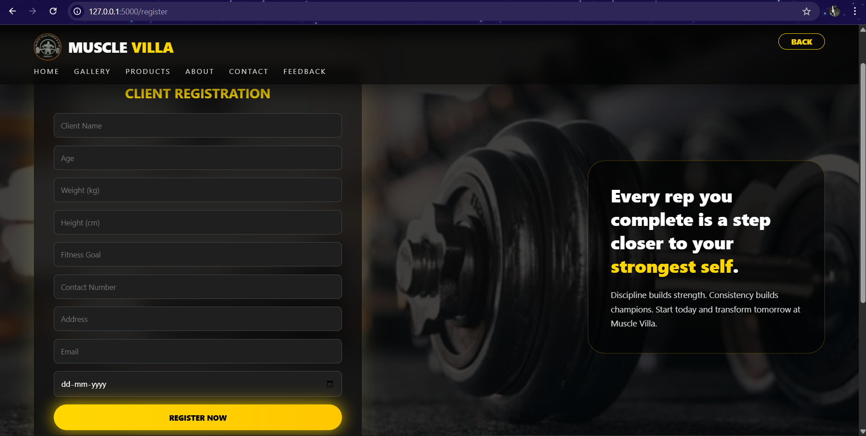

membership.html:
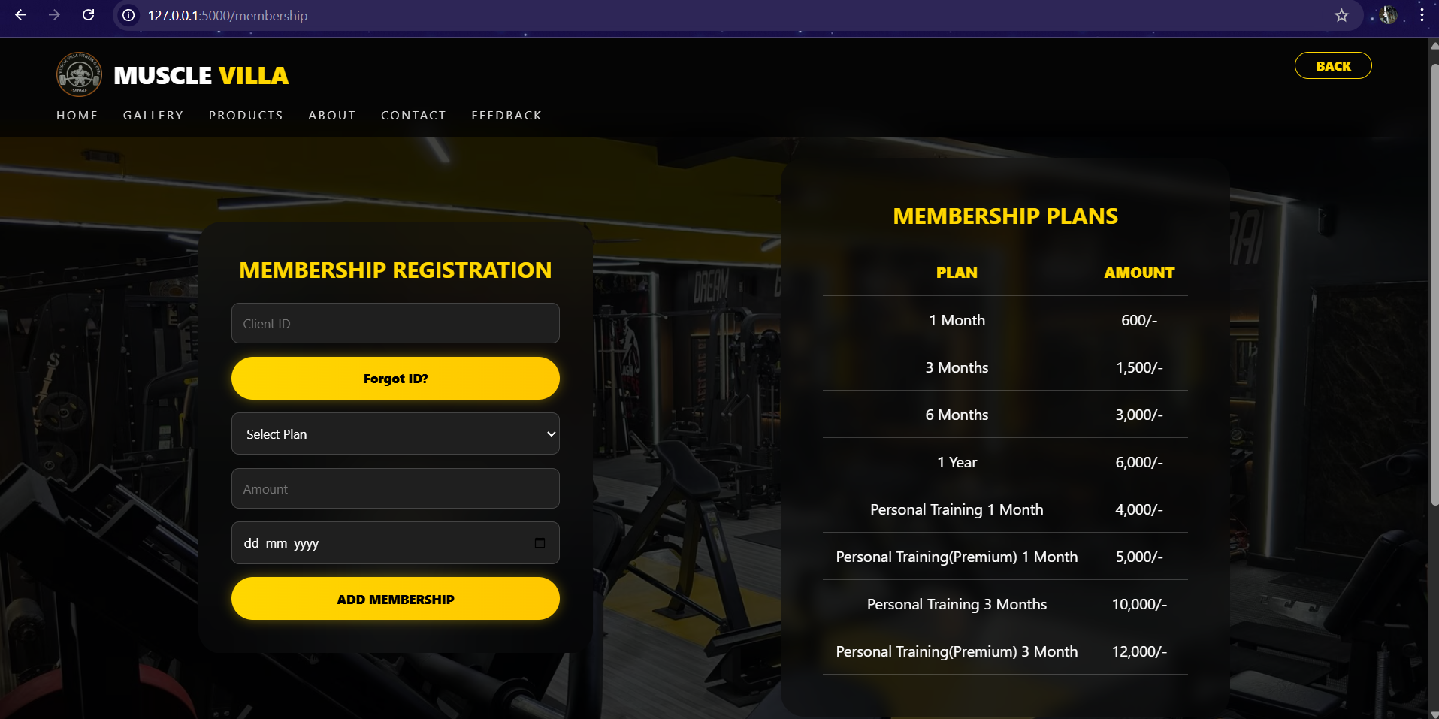

admin_dashboard.html:
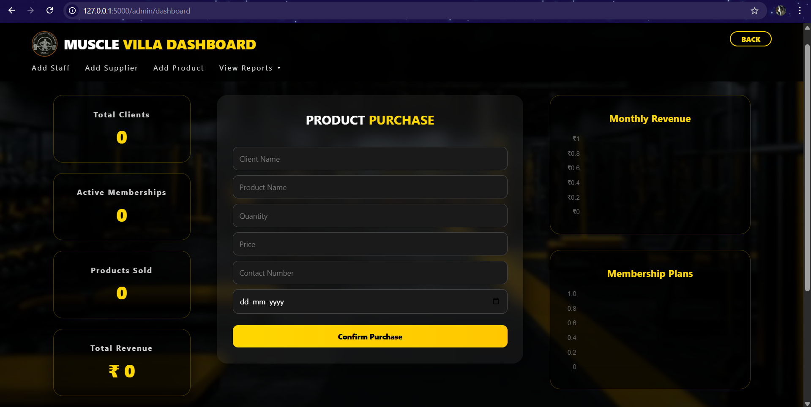

admin_staff:
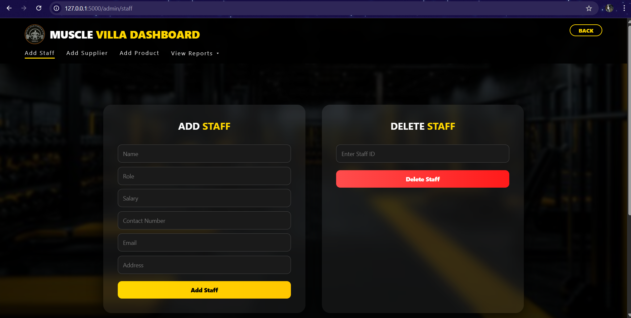

admin_supplier:
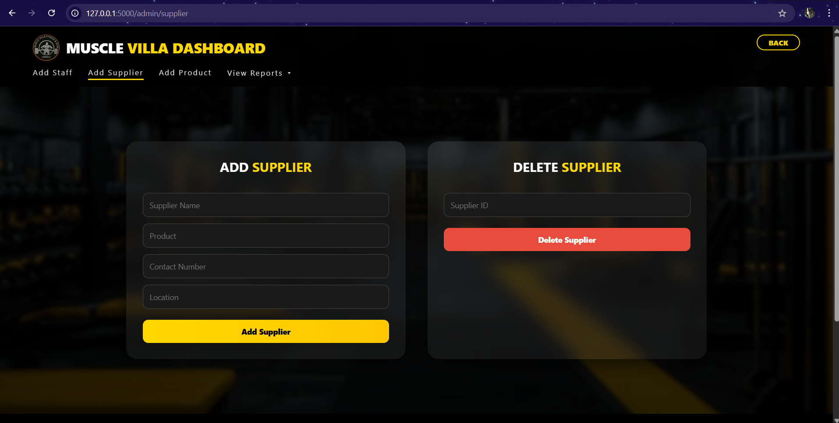

admin_product:
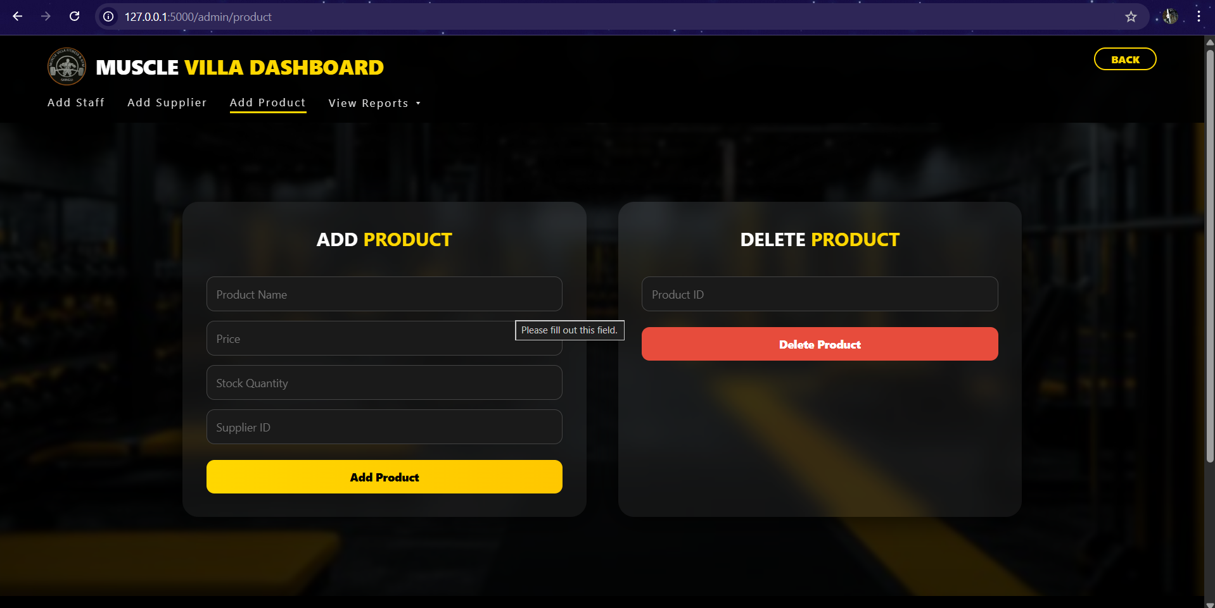

- With data:
register.html:
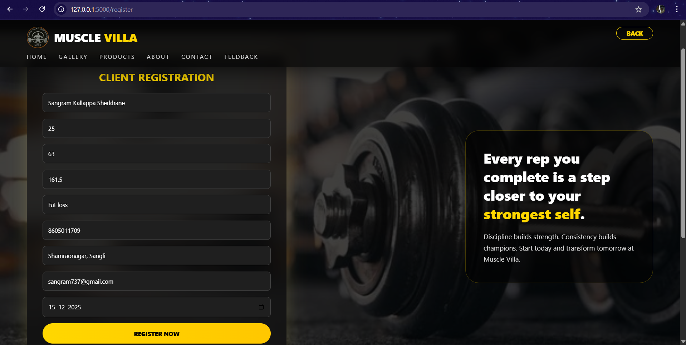

membership.html:
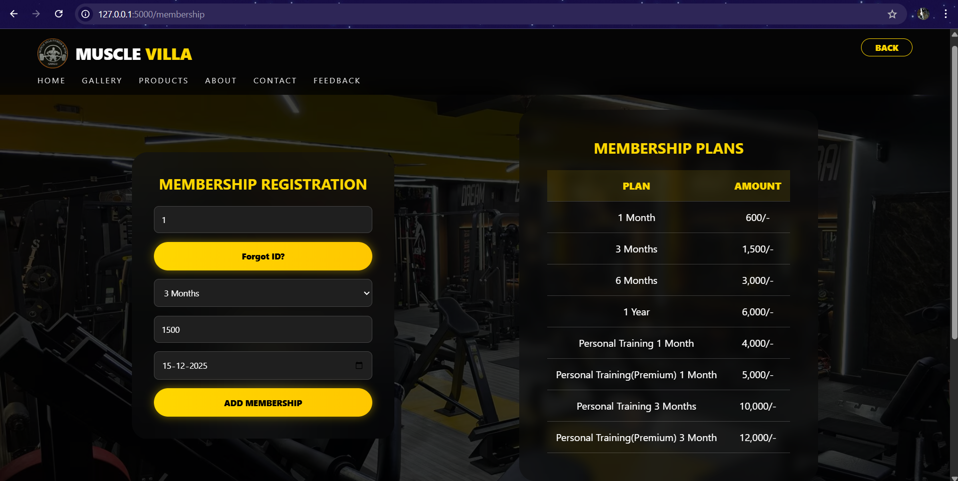

admin_dashboard.html:
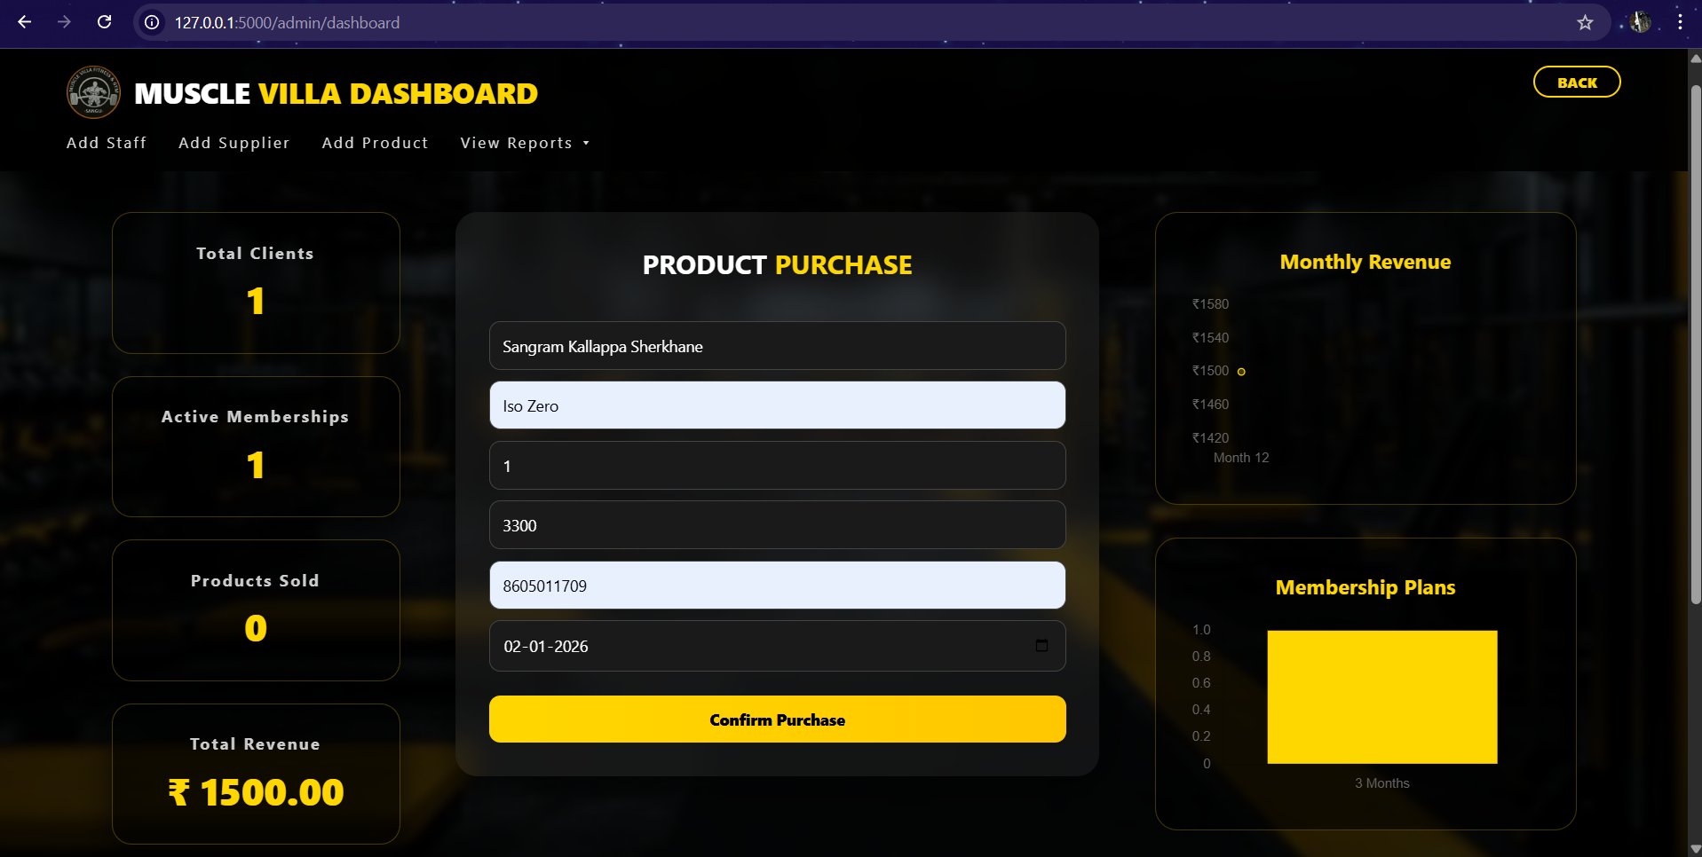

admin_staff:
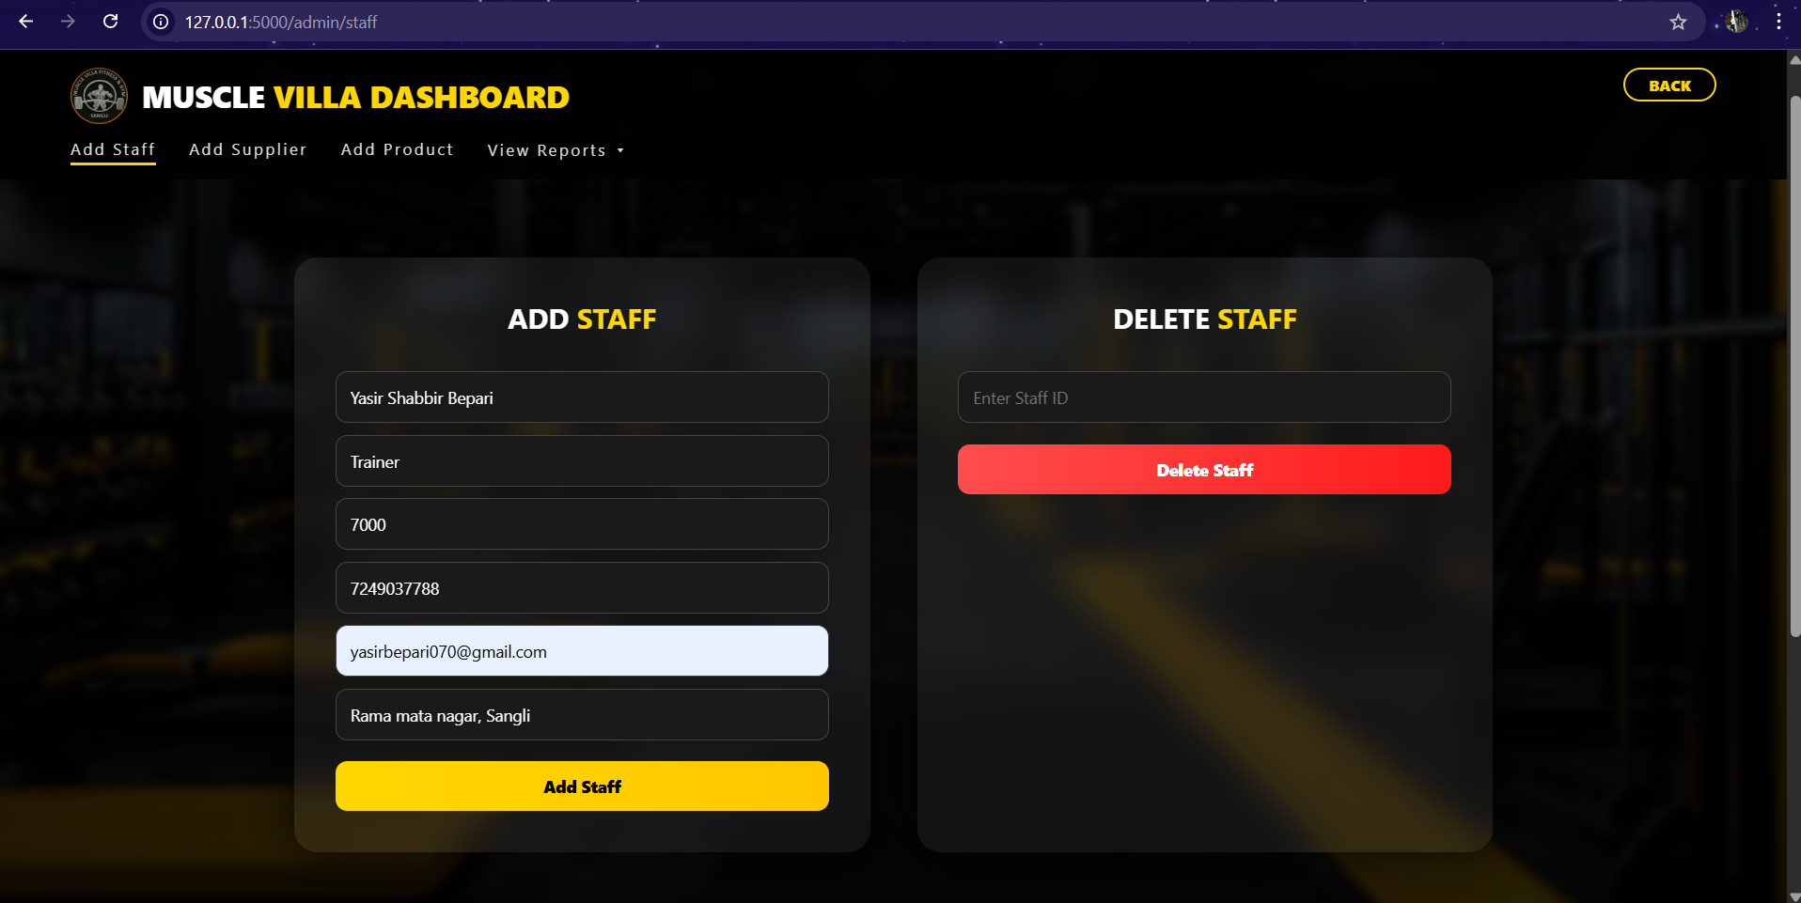

admin_supplier:


admin_product:


  - Output Design:

  - Source Code:
db.sql:
CREATE DATABASE muscle_villa;
USE muscle_villa;

-- ADMIN TABLE
CREATE TABLE admin (
admin_id INT AUTO_INCREMENT PRIMARY KEY,
email VARCHAR(100) NOT NULL,
password VARCHAR(100)NOT NULL
);

INSERT INTO admin (email, password)
VALUES ('musclevilla070@gmail.com', 'musclevilla2587');

-- CLIENT TABLE
CREATE TABLE client (
client_id INT AUTO_INCREMENT PRIMARY KEY,
name VARCHAR(100),
age INT,
weight FLOAT,
height FLOAT,
goal VARCHAR(100),
contact_number DOUBLE,
address VARCHAR(200),
email VARCHAR(100),
joining_date DATE
);

-- STAFF TABLE
CREATE TABLE staff (
staff_id INT AUTO_INCREMENT PRIMARY KEY,
name VARCHAR(100),
role VARCHAR(50),
salary DECIMAL(10,2),
contact DOUBLE,
email VARCHAR(100),
address VARCHAR(200)
);

-- SUPPLIER TABLE
CREATE TABLE supplier (
supplier_id INT AUTO_INCREMENT PRIMARY KEY,
supplier_name VARCHAR(100),
product VARCHAR(100),
contact_number DOUBLE,
location VARCHAR(100)
);

-- PRODUCT TABLE
CREATE TABLE product (
product_id INT AUTO_INCREMENT PRIMARY KEY,
name VARCHAR(100),
price DECIMAL(10,2),
stock INT,
supplier_id INT,
FOREIGN KEY (supplier_id) REFERENCES supplier(supplier_id)
);

-- MEMBERSHIP TABLE
CREATE TABLE membership (
membership_id INT AUTO_INCREMENT PRIMARY KEY,
client_id INT,
plan VARCHAR(50),
amount DECIMAL(10,2),
membership_date DATE,
FOREIGN KEY (client_id) REFERENCES client(client_id)
);

-- PURCHASE TABLE
CREATE TABLE purchase (
purchase_id INT AUTO_INCREMENT PRIMARY KEY,
client_name VARCHAR(100),
product_name VARCHAR(100),
quantity INT,
price DECIMAL(10,2),
contact_number DOUBLE,
purchase_date DATE
);

-- FEEDBACK TABLE
CREATE TABLE feedback (
feedback_id INT AUTO_INCREMENT PRIMARY KEY,
client_name VARCHAR(100),
email VARCHAR(100),
message TEXT,
stars INT
);

app.py:
from flask import Flask, render_template, request, redirect
import mysql.connector
from flask import jsonify

app = Flask(__name__)

# DATABASE CONNECTION
db = mysql.connector.connect(
host="localhost",
user="root",
password="root111",
database="muscle_villa"
)
cursor = db.cursor()

# HOME
@app.route("/")
def home():
return render_template("home.html")

# STATIC PAGES
@app.route("/gallery")
def gallery():
return render_template("gallery.html")

@app.route("/products")
def products():
return render_template("products.html")

@app.route("/about")
def about():
return render_template("about.html")

@app.route("/contact")
def contact():
return render_template("contact.html")

# FEEDBACK
@app.route("/feedback", methods=["GET", "POST"])
def feedback():

# ---------- SAVE FEEDBACK ----------
if request.method == "POST":
cursor.execute(
"""
INSERT INTO feedback (client_name, email, message, stars)
VALUES (%s, %s, %s, %s)
""",
(
request.form["client_name"],
request.form["email"],
request.form["message"],
request.form["stars"]
)
)
db.commit()

# stay on feedback page after submit
return redirect("/feedback")

# ---------- FETCH FEEDBACK ----------
cursor.execute(
"""
SELECT client_name, message, stars
FROM feedback
ORDER BY feedback_id DESC
"""
)
reviews = cursor.fetchall()

return render_template("feedback.html", reviews=reviews)

# CLIENT REGISTRATION
@app.route("/register", methods=["GET", "POST"])
def register():
if request.method == "POST":
cursor.execute("""
INSERT INTO client
(name, age, weight, height, goal, contact_number, address, email, joining_date)
VALUES (%s,%s,%s,%s,%s,%s,%s,%s,%s)
""", (
request.form["name"],
request.form["age"],
request.form["weight"],
request.form["height"],
request.form["goal"],
request.form["contact_number"],
request.form["address"],
request.form["email"],
request.form["joining_date"]
))
db.commit()
# GET AUTO GENERATED CLIENT ID
client_id = cursor.lastrowid
# SEND IT TO TEMPLATE
return render_template("register.html", client_id=client_id)
return render_template("register.html")

# MEMBERSHIP
@app.route("/membership", methods=["GET", "POST"])
def membership():
if request.method == "POST":
cursor.execute("""
INSERT INTO membership (client_id, plan, amount, membership_date)
VALUES (%s,%s,%s,%s)
""", (
request.form["client_id"],
request.form["plan"],
request.form["amount"],
request.form["membership_date"]
))
db.commit()
return redirect("/")
return render_template("membership.html")

@app.route("/get-client-id", methods=["POST"])
def get_client_id():
data = request.get_json()
contact = data["contact_number"]

cursor.execute(
"SELECT client_id FROM client WHERE contact_number=%s",
(contact,)
)
row = cursor.fetchone()

if row:
return jsonify(success=True, client_id=row[0])
return jsonify(success=False)

# ADMIN LOGIN
@app.route("/admin/login", methods=["GET", "POST"])
def admin_login():
if request.method == "POST":
cursor.execute(
"SELECT * FROM admin WHERE email=%s AND password=%s",
(request.form["email"], request.form["password"])
)
if cursor.fetchone():
return redirect("/admin/dashboard")
return "Invalid Admin Login"
return render_template("admin_login.html")

# ADMIN DASHBOARD
@app.route("/admin/dashboard")
def admin_dashboard():

cursor.execute("SELECT COUNT(*) FROM client")
total_clients = cursor.fetchone()[0]

cursor.execute("SELECT COUNT(*) FROM membership")
total_memberships = cursor.fetchone()[0]

cursor.execute("SELECT SUM(quantity) FROM purchase")
total_products_sold = cursor.fetchone()[0] or 0

cursor.execute("SELECT SUM(price) FROM purchase")
product_revenue = cursor.fetchone()[0] or 0

cursor.execute("SELECT SUM(amount) FROM membership")
membership_revenue = cursor.fetchone()[0] or 0

total_revenue = product_revenue + membership_revenue

cursor.execute("""
SELECT month, SUM(total) FROM (
SELECT MONTH(purchase_date) AS month, SUM(price) AS total
FROM purchase
GROUP BY MONTH(purchase_date)

UNION ALL

SELECT MONTH(membership_date) AS month, SUM(amount) AS total
FROM membership
GROUP BY MONTH(membership_date)
) AS combined
GROUP BY month
ORDER BY month
""")

rev = cursor.fetchall()
revenue_labels = [f"Month {r[0]}" for r in rev]
revenue_values = [r[1] for r in rev]

cursor.execute("SELECT plan, COUNT(*) FROM membership GROUP BY plan")
plans = cursor.fetchall()
plan_labels = [p[0] for p in plans]
plan_values = [p[1] for p in plans]

return render_template(
"admin_dashboard.html",
total_clients=total_clients,
total_memberships=total_memberships,
total_products_sold=total_products_sold,
total_revenue=total_revenue,
revenue_labels=revenue_labels,
revenue_values=revenue_values,
plan_labels=plan_labels,
plan_values=plan_values
)

# STAFF
@app.route("/admin/staff")
def admin_staff():
cursor.execute("SELECT * FROM staff")
data = cursor.fetchall()
return render_template("admin_staff.html", data=data)

@app.route("/admin/add_staff", methods=["POST"])
def add_staff():
cursor.execute("""
INSERT INTO staff (name, role, salary, contact, email, address)
VALUES (%s,%s,%s,%s,%s,%s)
""", (
request.form["name"],
request.form["role"],
request.form["salary"],
request.form["contact"],
request.form["email"],
request.form["address"]
))
db.commit()
return redirect("/admin/staff")

# SUPPLIER
@app.route("/admin/supplier")
def admin_supplier():
cursor.execute("SELECT * FROM supplier")
data = cursor.fetchall()
return render_template("admin_supplier.html", data=data)

@app.route("/admin/add_supplier", methods=["POST"])
def add_supplier():
cursor.execute("""
INSERT INTO supplier
(supplier_name, product, contact_number, location)
VALUES (%s,%s,%s,%s)
""", (
request.form["supplier_name"],
request.form["product"],
request.form["contact_number"],
request.form["location"]
))
db.commit()
return redirect("/admin/supplier")

# PRODUCT
@app.route("/admin/product")
def admin_product():
cursor.execute("SELECT * FROM product")
data = cursor.fetchall()
return render_template("add_product.html", data=data)

@app.route("/admin/add_product", methods=["POST"])
def add_product():
cursor.execute("""
INSERT INTO product (name, price, stock, supplier_id)
VALUES (%s,%s,%s,%s)
""", (
request.form["name"],
request.form["price"],
request.form["stock"],
request.form["supplier_id"]
))
db.commit()
return redirect("/admin/product")

# PURCHASE
@app.route("/purchase", methods=["POST"])
def purchase():
cursor.execute("""
INSERT INTO purchase
(client_name, product_name, quantity, price, contact_number, purchase_date)
VALUES (%s,%s,%s,%s,%s,%s)
""", (
request.form["client_name"],
request.form["product_name"],
request.form["quantity"],
request.form["price"],
request.form["contact_number"],
request.form["purchase_date"]
))
db.commit()
return redirect("/admin/dashboard")

# REPORTS
@app.route("/admin/reports/client")
def client_report():
cursor.execute("SELECT * FROM client")
return render_template("reports/client_report.html", data=cursor.fetchall())

@app.route("/admin/reports/membership")
def membership_report():
cursor.execute("SELECT * FROM membership")
return render_template("reports/membership_report.html", data=cursor.fetchall())

@app.route("/admin/reports/staff")
def staff_report():
cursor.execute("SELECT * FROM staff")
return render_template("reports/staff_report.html", data=cursor.fetchall())

@app.route("/admin/reports/supplier")
def supplier_report():
cursor.execute("SELECT * FROM supplier")
return render_template("reports/supplier_report.html", data=cursor.fetchall())

@app.route("/admin/reports/inventory")
def inventory_report():
cursor.execute("SELECT * FROM product")
return render_template("reports/inventory_report.html", data=cursor.fetchall())

@app.route("/admin/reports/purchase")
def purchase_report():
cursor.execute("SELECT * FROM purchase")
return render_template("reports/purchase_report.html", data=cursor.fetchall())

@app.route("/admin/reports/feedback")
def feedback_report():
cursor.execute("SELECT * FROM feedback")
return render_template("reports/feedback_report.html", data=cursor.fetchall())

# RUN SERVER
if __name__ == "__main__":
app.run(debug=True)

register.html:
<!DOCTYPE html>
<html lang="en">
<head>
<meta charset="UTF-8">
<meta name="viewport" content="width=device-width, initial-scale=1.0">
<title>Muscle Villa | Register</title>
</head>
<body>
<div class="navbar">
<div>
<div class="brand">
<img src="{{ url_for('static', filename='images/logo.png') }}">
<span>MUSCLE <b>VILLA</b></span>
</div>
<div class="nav-links">
<a href="/">HOME</a>
<a href="/gallery">GALLERY</a>
<a href="/products">PRODUCTS</a>
<a href="/about">ABOUT</a>
<a href="/contact">CONTACT</a>
<a href="/feedback">FEEDBACK</a>
</div>
</div>
<button class="back-btn" onclick="history.back()">BACK</button>
</div>

<section class="register-section">

<div class="register-box">
<h2>CLIENT REGISTRATION</h2>
<form action="/register" method="post">
<input name="name" placeholder="Client Name" required> <input name="age" type="number" placeholder="Age" required>
<input name="weight" type="number" step="0.1" placeholder="Weight (kg)" required>
<input name="height" type="number" step="0.1" placeholder="Height (cm)" required>
<input name="goal" placeholder="Fitness Goal" required>
<input name="contact_number" placeholder="Contact Number" required>
<input name="address" placeholder="Address" required>
<input name="email" type="email" placeholder="Email" required>
<input name="joining_date" type="date" required>
<button type="submit">REGISTER NOW</button>
</form>
</div>

<div class="quote-box">
<h3>
Every rep you complete is a step closer to your <span>strongest self</span>.
</h3>
<p>
Discipline builds strength. Consistency builds champions.
Start today and transform tomorrow at Muscle Villa.
</p>
</div>
</section>
<footer>
<h3>Muscle Villa</h3>
<p>Premium Fitness & Supplement Management System</p>
</div>
</footer>

<div class="footer-bottom">
© 2026 Muscle Villa. All Rights Reserved.
</div>

<script>
window.addEventListener("scroll", () => {
document.querySelector(".navbar")
.classList.toggle("scrolled", window.scrollY > 20);
});
{% if client_id %}
window.onload = function () {
alert("✅ Registration Successful!\n\nYour Client ID is: {{ client_id }}");
};
{% endif %}
</script>
</body>
</html>

membership.html:
<!DOCTYPE html>
<html lang="en">
<head>
<meta charset="UTF-8">
<meta name="viewport" content="width=device-width, initial-scale=1.0">
<title>Muscle Villa | Membership</title>
</head>
<body>
<div class="navbar">
<div>
<div class="brand">
<img src="{{ url_for('static', filename='images/logo.png') }}">
<span>MUSCLE <b>VILLA</b></span>
</div>
<div class="nav-links">
<a href="/">HOME</a>
<a href="/gallery">GALLERY</a>
<a href="/products">PRODUCTS</a>
<a href="/about">ABOUT</a>
<a href="/contact">CONTACT</a>
<a href="/feedback">FEEDBACK</a>
</div>
</div>
<button class="back-btn" onclick="history.back()">BACK</button>
</div>

<section class="membership-section">
<div class="membership-box">
<h2>MEMBERSHIP REGISTRATION</h2>
<form action="/membership" method="post">
<input id="clientIdInput" name="client_id" type="number" placeholder="Client ID" required>

<button type="button" class="forgot-btn" onclick="openForgotModal()">
Forgot ID?
</button>
<select name="plan" id="planSelect" required>
<option value="">Select Plan</option>
<option>1 Month</option>
<option>3 Months</option>
<option>6 Months</option>
<option>1 Year</option>
<option>Personal Training 1 Month</option>
<option>Personal Training(Premium) 1 Month</option>
<option>Personal Training 3 Months</option>
<option>Personal Training(Premium) 3 Months</option>
</select>
<input id="amountInput" name="amount" type="number" placeholder="Amount" required readonly>
<input name="membership_date" type="date" required>
<button type="submit">ADD MEMBERSHIP</button>
</form>
</div>
<div class="plan-table">
<h2>MEMBERSHIP PLANS</h2>
<table>
<tr>
<th>PLAN</th>
<th>AMOUNT</th>
</tr>
<tr>
<td>1 Month</td>
<td>600/-</td>
</tr>
<tr>
<td>3 Months</td>
<td>1,500/-</td>
</tr>
<tr>
<td>6 Months</td>
<td>3,000/-</td>
</tr>
<tr>
<td>1 Year</td>
<td>6,000/-</td>
</tr>
<tr>
<td>Personal Training 1 Month</td>
<td>4,000/-</td>
</tr>
<tr>
<td>Personal Training(Premium) 1 Month</td>
<td>5,000/-</td>
</tr>
<tr>
<td>Personal Training 3 Months</td>
<td>10,000/-</td>
</tr>
<tr>
<td>Personal Training(Premium) 3 Month</td>
<td>12,000/-</td>
</tr>
</table>
</div>
</section>
</script>
</body>
</html>

admin_dashboard.html:
<!DOCTYPE html>
<html lang="en">
<head>
<meta charset="UTF-8">
<title>Admin Dashboard | Muscle Villa</title>
<meta name="viewport" content="width=device-width, initial-scale=1.0">
</head>
<body>
<div class="navbar">
<div class="nav-left">
<div class="brand">
<img src="/static/images/logo.png">
<div class="brand-text">MUSCLE <span>VILLA DASHBOARD</span></div>
</div>
<div class="nav-links">
<a href="/admin/staff">Add Staff</a>
<a href="/admin/supplier">Add Supplier</a>
<a href="/admin/product">Add Product</a>
<div class="dropdown">
<div class="dropdown-content" id="reportDropdown">
<a href="/admin/reports/client">Client Report</a>
<a href="/admin/reports/membership">Membership Report</a>
<a href="/admin/reports/staff">Staff Report</a>
<a href="/admin/reports/supplier">Supplier Report</a>
<a href="/admin/reports/inventory">Inventory Report</a>
<a href="/admin/reports/purchase">Purchase Report</a>
<a href="/admin/reports/feedback">Feedback Report</a>
</div>
</div>
</div>
</div>
<a href="/admin/dashboard" class="dashboard-btn">BACK</a>
</div>
<div class="dashboard-layout">
<div class="dashboard-left">
<div class="stats-grid">
<div class="stat-card">
<h4>Total Clients</h4>
<p>{{ total_clients }}</p>
</div>

<div class="stat-card">
<h4>Active Memberships</h4>
<p>{{ total_memberships }}</p>
</div>

<div class="stat-card">
<h4>Products Sold</h4>
<p>{{ total_products_sold }}</p>
</div>

<div class="stat-card">
<h4>Total Revenue</h4>
<p>₹ {{ total_revenue }}</p>
</div>
</div>
</div>
<div class="dashboard-center">
<div class="container">
<h2>PRODUCT <span>PURCHASE</span></h2>
<form action="/purchase" method="post">
<input name="client_name" placeholder="Client Name" required>
<input name="product_name" placeholder="Product Name" required>
<input name="quantity" type="number" placeholder="Quantity" required>
<input name="price" type="number" placeholder="Price" required>
<input name="contact_number" placeholder="Contact Number" required>
<input name="purchase_date" type="date" required>
<button>Confirm Purchase</button>
</form>
</div>
</div>
<div class="dashboard-right">
<div class="chart-box">
<h3>Monthly Revenue</h3>
<canvas id="revenueChart"></canvas>
</div>

<div class="chart-box">
<h3>Membership Plans</h3>
<canvas id="membershipChart"></canvas>
</div>
</div>

</div>
<footer>
<div>
<h3>Muscle Villa</h3>
<p>Premium Fitness & Supplement Management System</p>
</div>
</footer>
<div class="copy">
© 2026 Muscle Villa | Admin Panel
</div>
<script src="https://cdn.jsdelivr.net/npm/chart.js"></script>
<script>
function toggleDropdown() {
document.getElementById("reportDropdown").classList.toggle("show");
}
window.onclick = function (e) {
if (!e.target.matches('.view-report-btn')) {
let d = document.getElementById("reportDropdown");
if (d && d.classList.contains("show")) {
d.classList.remove("show");
}
}
};
options: {
responsive: true,
plugins: {
legend: { display: false }
},
scales: {
y: {
ticks: {
callback: value => "₹" + value
}
}
}
}
});
}
const membershipCtx = document.getElementById("membershipChart");
if (membershipCtx) {
new Chart(membershipCtx, {
type: "bar",
data: {
labels: planLabels,
datasets: [{
label: "Members",
data: planValues,
backgroundColor: "#FFD700"
}]
},
options: {
responsive: true,
plugins: {
legend: { display: false }
}
}
});
}
</script>
</body>
</html>

admin_staff:
<!DOCTYPE html>
<html lang="en">
<head>
<meta charset="UTF-8">
<title>Admin | Staff Management - Muscle Villa</title>
<meta name="viewport" content="width=device-width, initial-scale=1.0">
</head>
<body>
<div class="navbar">
<div class="nav-left">
<div class="brand">
<img src="/static/images/logo.png">
<div class="brand-text">MUSCLE <span>VILLA DASHBOARD</span></div>
</div>
<div class="nav-links">
<a href="/admin/staff" class="active">Add Staff</a>
<a href="/admin/supplier">Add Supplier</a>
<a href="/admin/product">Add Product</a>
<div class="dropdown">
<span class="view-report-btn" onclick="toggleDropdown()">View Reports ▾</span>
<div class="dropdown-content" id="reportDropdown">
<a href="/admin/reports/client">Client Report</a>
<a href="/admin/reports/membership">Membership Report</a>
<a href="/admin/reports/staff">Staff Report</a>
<a href="/admin/reports/supplier">Supplier Report</a>
<a href="/admin/reports/inventory">Inventory Report</a>
<a href="/admin/reports/purchase">Purchase Report</a>
<a href="/admin/reports/feedback">Feedback Report</a>
</div>
</div>
</div>
</div>
<a href="/admin/dashboard" class="dashboard-btn">BACK</a>
</div>
<div class="grid">
<div class="card">
<h2>ADD <span>STAFF</span></h2>
<form action="/admin/add_staff" method="post">
<input name="name" placeholder="Name" required>
<input name="role" placeholder="Role" required>
<input name="salary" type="number" placeholder="Salary" required>
<input name="contact" placeholder="Contact Number" required>
<input name="email" placeholder="Email" required>
<input name="address" placeholder="Address" required>
<button>Add Staff</button>
</form>
</div>
<div class="card">
<h2>DELETE <span>STAFF</span></h2>
<form action="/admin/delete_staff" method="post">
<input name="staff_id" type="number" placeholder="Enter Staff ID" required>
<button class="delete-btn">Delete Staff</button>
</form>
</div>
</div>
<footer>
<div>
<h3>Muscle Villa</h3>
<p>Premium Fitness & Supplement Management System</p>
</div>
</footer>
<div class="copy">
© 2026 Muscle Villa | Admin Panel
</div>
</body>
</html>

admin_supplier:
<!DOCTYPE html>
<html lang="en">
<head>
<meta charset="UTF-8">
<title>Admin | Supplier Management - Muscle Villa</title>
<meta name="viewport" content="width=device-width, initial-scale=1.0">
</head>
<body>
<div class="navbar">
<div class="nav-left">
<div class="brand">
<img src="/static/images/logo.png">
<div class="brand-text">MUSCLE <span>VILLA DASHBOARD</span></div>
</div>

<div class="nav-links">
<a href="/admin/staff">Add Staff</a>
<a href="/admin/supplier" class="active">Add Supplier</a>
<a href="/admin/product">Add Product</a>

<div class="dropdown">
<span class="view-report-btn" onclick="toggleDropdown()">View Reports ▾</span>
<div class="dropdown-content" id="reportDropdown">
<a href="/admin/reports/client">Client Report</a>
<a href="/admin/reports/membership">Membership Report</a>
<a href="/admin/reports/staff">Staff Report</a>
<a href="/admin/reports/supplier">Supplier Report</a>
<a href="/admin/reports/inventory">Inventory Report</a>
<a href="/admin/reports/purchase">Purchase Report</a>
<a href="/admin/reports/feedback">Feedback Report</a>
</div>
</div>
</div>
</div>
<a href="/admin/dashboard" class="dashboard-btn">BACK</a>
</div>
<div class="main">
<div class="card">
<h2>ADD <span>SUPPLIER</span></h2>
<form action="/admin/add_supplier" method="post">
<input name="supplier_name" placeholder="Supplier Name" required>
<input name="product" placeholder="Product" required>
<input name="contact_number" placeholder="Contact Number" required>
<input name="location" placeholder="Location" required>
<button>Add Supplier</button>
</form>
</div>
<div class="card">
<h2>DELETE <span>SUPPLIER</span></h2>
<form action="/admin/delete_supplier" method="post">
<input name="supplier_id" type="number" placeholder="Supplier ID" required>
<button class="delete-btn">Delete Supplier</button>
</form>
</div>
</div>
<footer>
<div>
<h3>Quick Links</h3>
<a href="/admin/staff">Staff</a>
<a href="/admin/supplier">Suppliers</a>
<a href="/admin/product">Products</a>
<a href="/admin/dashboard">Dashboard</a>
</div>

<div>
<h3>Quick Reports</h3>
<a href="/admin/reports/client">Client Report</a>
<a href="/admin/reports/membership">Membership Report</a>
<a href="/admin/reports/purchase">Purchase Report</a>
<a href="/admin/reports/feedback">Feedback</a>
</div>

<div>
<h3>Muscle Villa</h3>
<p>Premium Fitness & Supplement Management System</p>
</div>
</footer>

<div class="copy">
© 2026 Muscle Villa | Admin Panel
</div>
</body>
</html>

admin_product:
<!DOCTYPE html>
<html lang="en">
<head>
<meta charset="UTF-8">
<title>Admin | Product Management - Muscle Villa</title>
<meta name="viewport" content="width=device-width, initial-scale=1.0">
</head>
<body>
<div class="navbar">
<div class="nav-left">
<div class="brand">
<img src="/static/images/logo.png">
<div class="brand-text">MUSCLE <span>VILLA DASHBOARD</span></div>
</div>
<div class="nav-links">
<a href="/admin/staff">Add Staff</a>
<a href="/admin/supplier">Add Supplier</a>
<a href="/admin/product" class="active">Add Product</a>
<div class="dropdown">
<span class="view-report-btn" onclick="toggleDropdown()">View Reports ▾</span>
<div class="dropdown-content" id="reportDropdown">
<a href="/admin/reports/client">Client Report</a>
<a href="/admin/reports/membership">Membership Report</a>
<a href="/admin/reports/staff">Staff Report</a>
<a href="/admin/reports/supplier">Supplier Report</a>
<a href="/admin/reports/inventory">Inventory Report</a>
<a href="/admin/reports/purchase">Purchase Report</a>
<a href="/admin/reports/feedback">Feedback Report</a>
</div>
</div>
</div>
</div>
<a href="/admin/dashboard" class="dashboard-btn">BACK</a>
</div>
<div class="main">
<div class="card">
<h2>ADD <span>PRODUCT</span></h2>
<form action="/admin/add_product" method="post">
<input name="name" placeholder="Product Name" required>
<input name="price" type="number" placeholder="Price" required>
<input name="stock" type="number" placeholder="Stock Quantity" required>
<input name="supplier_id" type="number" placeholder="Supplier ID" required>
<button>Add Product</button>
</form>
</div>
<div class="card">
<h2>DELETE <span>PRODUCT</span></h2>
<form action="/admin/delete_product" method="post">
<input name="product_id" type="number" placeholder="Product ID" required>
<button class="delete-btn">Delete Product</button>
</form>
</div>
</div>
<footer>
<div>
<h3>Quick Links</h3>
<a href="/admin/staff">Staff</a>
<a href="/admin/supplier">Suppliers</a>
<a href="/admin/product">Products</a>
<a href="/admin/dashboard">Dashboard</a>
</div>
<div>
<h3>Quick Reports</h3>
<a href="/admin/reports/client">Client Report</a>
<a href="/admin/reports/membership">Membership Report</a>
<a href="/admin/reports/purchase">Purchase Report</a>
<a href="/admin/reports/feedback">Feedback</a>
</div>
<div>
<h3>Muscle Villa</h3>
<p>Premium Fitness & Supplement Management System</p>
</div>
</footer>
<div class="copy">
© 2026 Muscle Villa | Admin Panel
</div>
</body>
</html>

  - User Manual:

Sr. No. | Menu | Description
1) | Home | The Home Tab serves as the main page and provides a brief overview of the website purpose and content, offering quick navigation to other sections.
2) | Types | The Types Tab provides detailed information about the various types of VFX & CGI. Users can explore different categories such as compositing, 3D modeling, motion capture and more, gaining a clear understanding of their importance in the VFX & CGI industry.
3) | Tools & Career | The Tools & Career Tab provide widely used tools and software in the VFX & CGI industry, such as Adobe After Effects, Blender, Maya, Nuke, and more. Additionally, it provides guidance on career options/job roles, required skills, and opportunities available in the field.
4) | Gallery | The Gallery Tab showcases a collection of images related to VFX & CGI work. It includes samples of effects, before-and-after transformations, creative projects, etc.
5) | About Us | The About Us Tab provides information about the website and mission and goals of the website & organization.
6) | Contact Us | The Contact Us Tab provide contact details of the organization, including email address, phone number, and location.
7) | Feedback | In Feedback Tab user can give reviews, and suggestions. It helps new visitors understand the website.

6.1 Conclusion & Further Enhancement:
Conclusion:
The VFX and CGI website serves as a comprehensive platform aimed at educating and inspiring individuals interested in the world of visual effects and computer-generated imagery. It provides detailed insights into industry-standard tools, career paths, educational resources, and project showcases. By bridging the gap between curiosity and professional knowledge, the platform empowers students, hobbyists, and aspiring professionals to explore and grow in the creative tech industry.

Future Enhancements:
To further improve the user experience and expand the website’s capabilities, several future enhancements are planned:
1. Interactive Tutorials & Courses:
Add step-by-step tutorials and online courses with interactive elements for Blender, Maya, Unreal Engine, and more.
2. Community Forum:
Introduce a community space where users can discuss, share work, get feedback, and collaborate on projects.
3. Portfolio Section for Users:
Allow users to create profiles and showcase their VFX/CGI work to gain visibility and networking opportunities.
4. Job & Internship Listings:
Integrate a job board for internships, freelance gigs, and job openings in the VFX/CGI industry.
5. AI-Powered Learning Path Suggestions:
Use AI to recommend personalized learning paths based on user interests and skill level.
6. Mobile App Version:
Develop a mobile application for easier access and learning on-the-go.
7. Regular Webinars & Expert Talks:
Host sessions with professionals in the industry to give learners firsthand knowledge and updates on current trends.

7.1 Bibliography:
Books Referred:
- Complete HTML – Thomas Powell
- HTML BlackBook – Steven Holzner
- Learning Web Design- Jennifer Niederst Robbins

Website Referred:
- https://www.w3schools.com/
- https://www.google.com/
- https://www.youtube.com/

